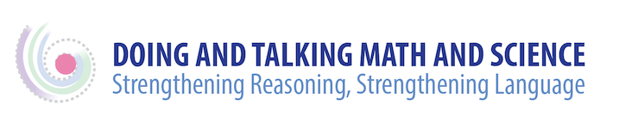

References Used in this Website

Heritage, M., Walqui, A., & Linquanti, R. (2015). English language learners and the new standards: Developing language, content knowledge, and analytical practices in the classroom. Cambridge, MA: Harvard University Press.
Lee, O., Quinn, H., & Valdés, G. (2013). Science and language for English language learners in relation to Next Generation Science Standards and with implications for Common Core State Standards for English language arts and mathematics. Educational Researcher, 42, (4): 223–244.
MacDonald, R. & Molle, D. (2015). Creating meaning through key practices in English language arts: Integrating practice, content, and language. In L. C. de Oliveira, M. Klassen, & M. Maune. (Eds.) The Common Core Standards in English language arts for English language learners: Grades 6-12 (pp. 39-52). Alexandria, VA: TESOL International.

Quinn, H. (2015). Science and engineering practices for equity: Creating opportunities for diverse students to learn science and develop foundational capacities. In O. Lee, E. Miller, & R. Januszyk. (Eds.) NGSS for All Students (pp. 7-20). Arlington, VA: National Science Teachers Association Press.
Schegloff, E. (2007). Sequence organization in interaction: A primer in conversation analysis
(Vol. 1). Cambridge, UK: Cambridge University Press.

