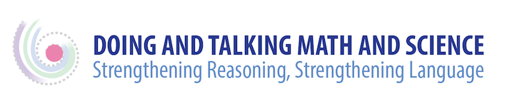

Science Resources for Meaning-making Activities

NSTA has some great activities. Go to https://www.nsta.org/
and then go to the drop-down menu Science Standards and choose Classroom Resources. This is the best site to find some curated lessons aligned to a cross-cutting concept, practice, or disciplinary core idea, or all three by searching under the performance Expectations at your grade level.

Here are some good videos of a new teacher http://ngss.nsta.org/ngss-videos.aspx

Instead of lessons, consider building activities around local phenomena. Here’s a site for that: http://wonderopolis.org/

These sites also have some good lessons:
- https://concord.org/publications/newsletter/2013-spring/meet-ngss

- http://www.calacademy.org/educators/lesson-plans

- wlresources.dpi.wi.gov

Here are some sites with good performance tasks:
- http://education.vermont.gov/assessment/necap/resources/released-test-items
- http://performanceassessmentresourcebank.org/
- http://ngss-assessment.portal.concord.org/

Ambitious Science Teaching is a great site. Check out their videos and the discourse primer! http://ambitiousscienceteaching.org/video-series/

Here’s a new and promising resource: http://learndbir.org/

