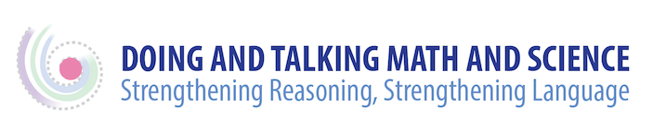

Suggestions for Additional Reading

Chapin, S., O’Connor, C., & Anderson, N. (2003). Classroom discussions: Using math talk to help students learn. Sausalito, CA: Math Solutions Publications.

Michaels, S., & O’Connor C. (2012) Talk Science Primer. Cambridge, MA:TERC.
Retrieved from http://inquiryproject.terc.edu/shared/pd/TalkScience_Primer.pdf

Miller, E., & MacDonald, R. (2015). Rethinking language goals in science: Can three-dimensional learning allow us to shift our thinking around science learning and language goals? Colorín Colorado TE.L.L.-EGRAM, Feb. 2015. Retrieved from www.colorincolorado.org/article/63672/

Zwiers, J., O’Hara, S., & Pritchard, R. (2014). Common Core Standards in diverse classrooms: Essential practices for developing academic language and disciplinary literacy. Portland, Maine: Stenhouse Publishers.

